Kadijatu Bah

09/28/2018

Lab 4

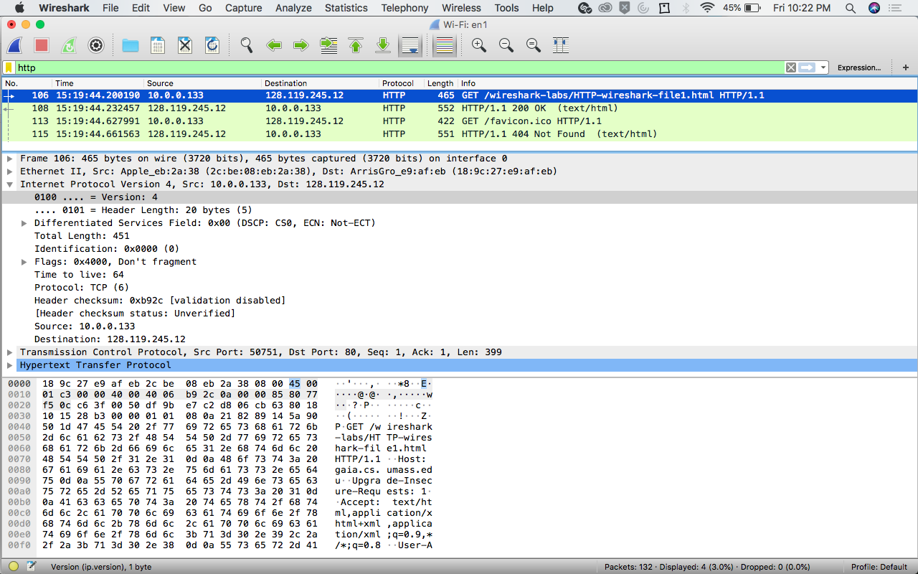

1. What is the IP address of your computer?

* **The IP address of my computer is 10.0.0133.**



1. What is the total length of the datagram?

* **The total length of the datagram is 451.**

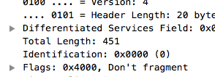

1. Has this IP datagram been fragmented?

* **The IP datagram has not been fragmented.**



1. How many bytes are in the IP header?

* **There are 20 bytes in the header.**



1. How many bytes are in the payload *of the IP datagram*? Explain how you determined the number of payload bytes.

* **The total length is 451, the header is 20 bytes. If you subtract 20 from 451, you’ll get 431. The payload for this website is 431.**



